Pickle_Rick_Solution_Documentation
Written by: Yuval Quina
- Info gathering:
I began this challenge by scanning open ports and services versions using Nmap:
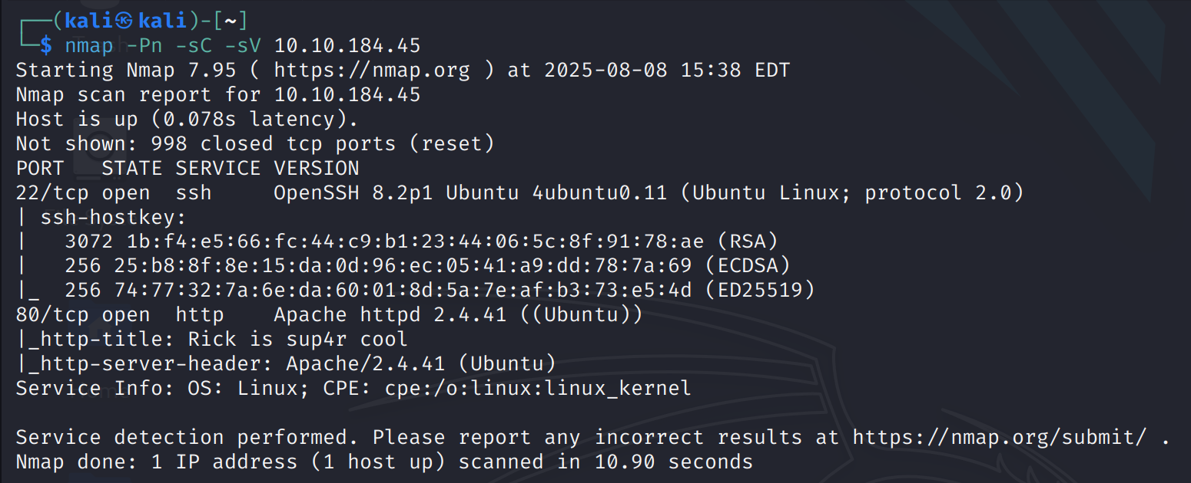
Then I entered the target website:
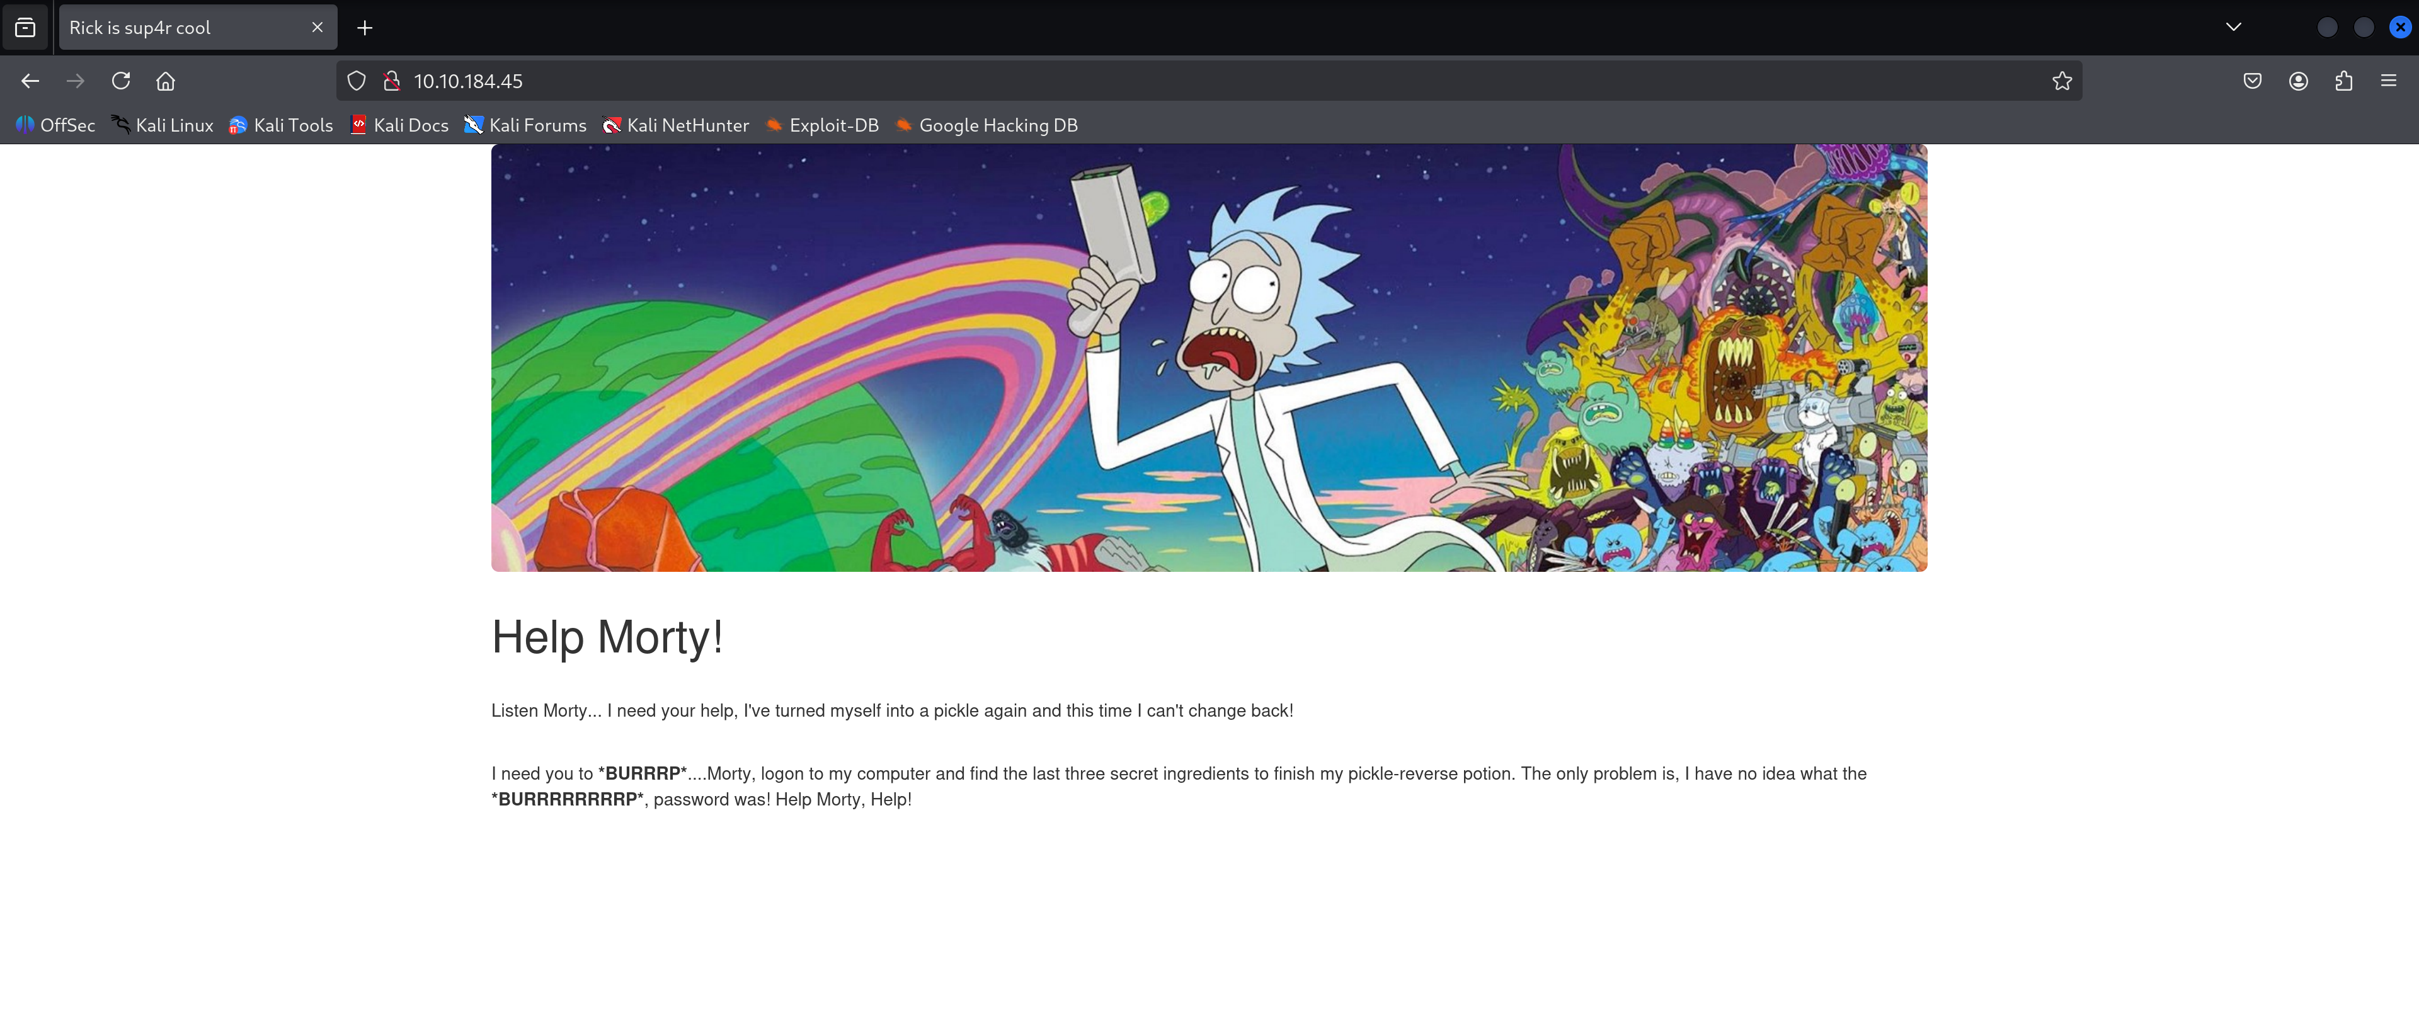
I read the text, entered the inspector and found rick’s user that was mentioned in the text:
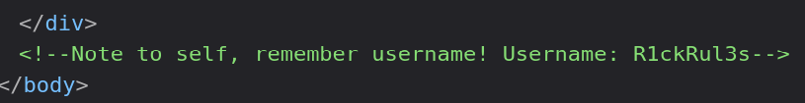
I tried to access the “robots.txt” file but it contained nothing useful:
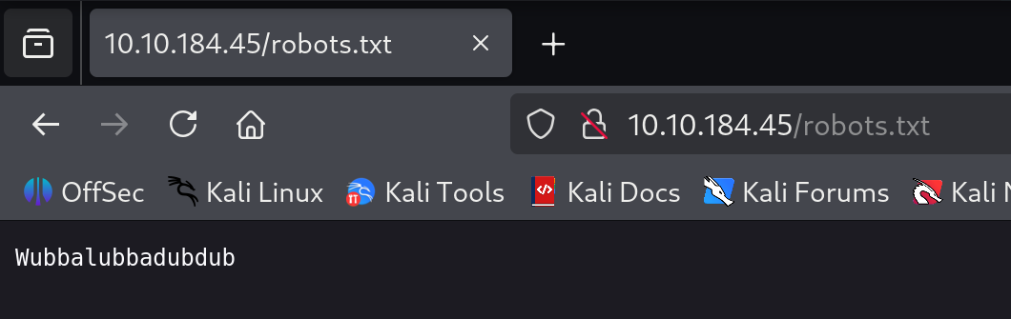
From this point, I moved to enumerate directories over the website using gobuster. Meanwhile, I tried to guess the path to the login page because if the user has been mentioned, probably, there should be a login page. I guessed correctly the “login.php” page:
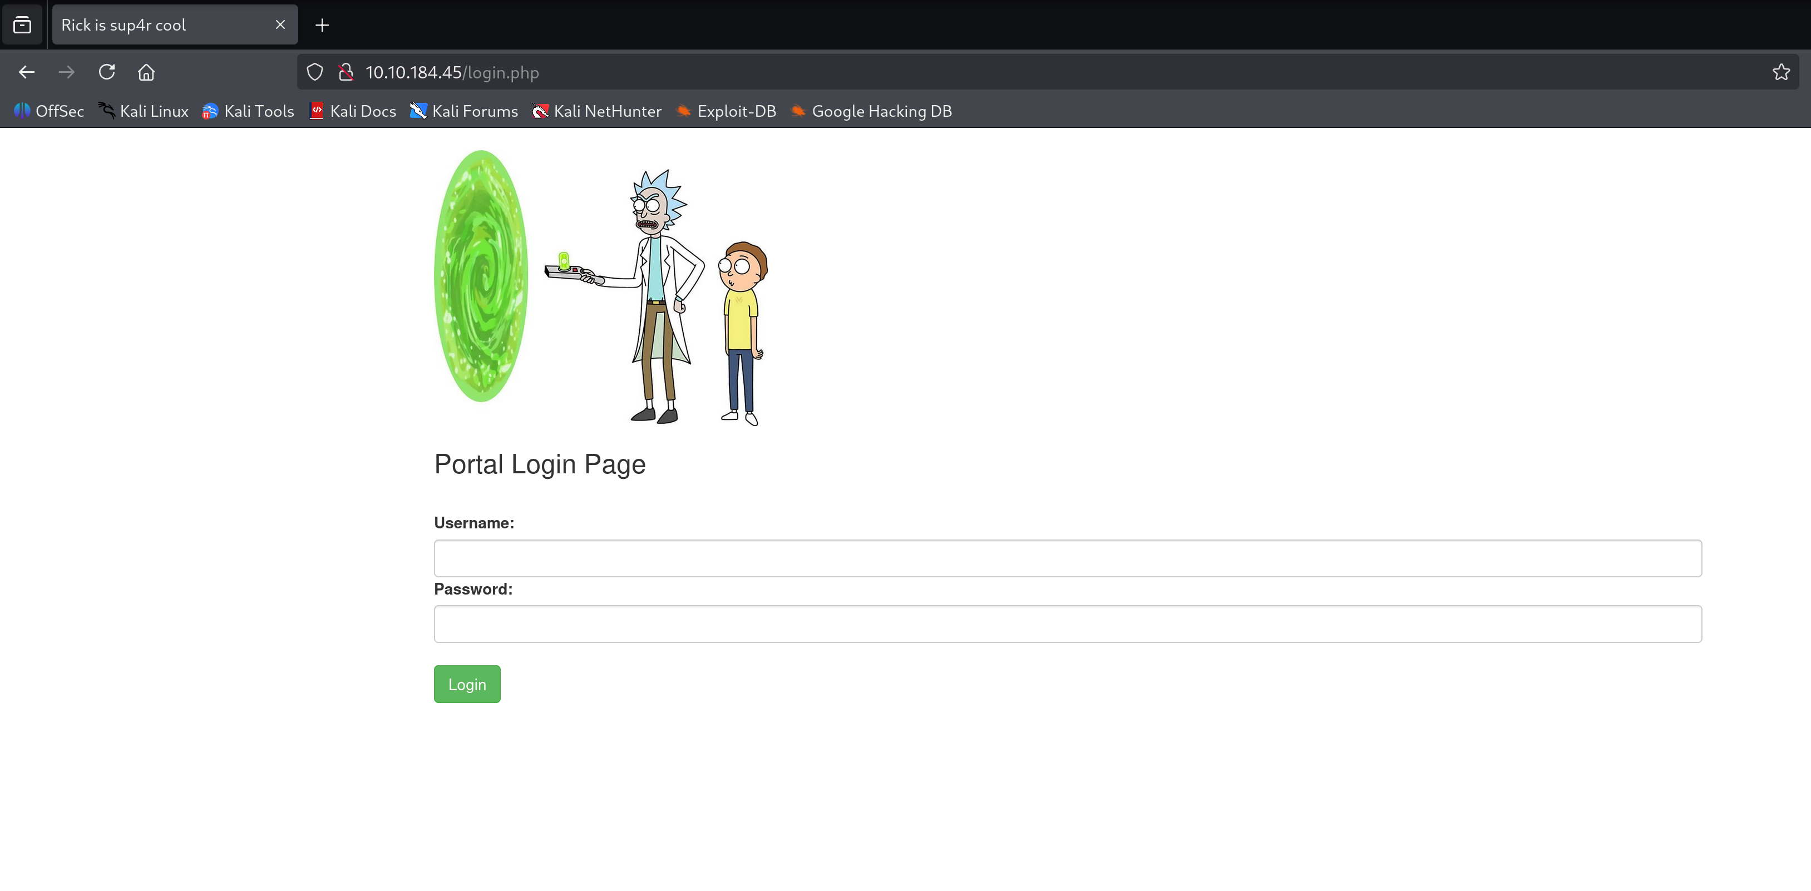
Now I tried to use the username with a random password and this message popped up:

- Vulnerability detection:

- Attacking:

- Privilege escalation:

